DEVOPS CI/CD PIPELINE

As steps given in the question the screenshots are placed accordingly

1.Implement a CI/CD pipeline using Jenkins multi-branch pipelines N.Jithendra

This github contains three branches: 289238

1.Develop

2.Feature/login

3.Release/v1

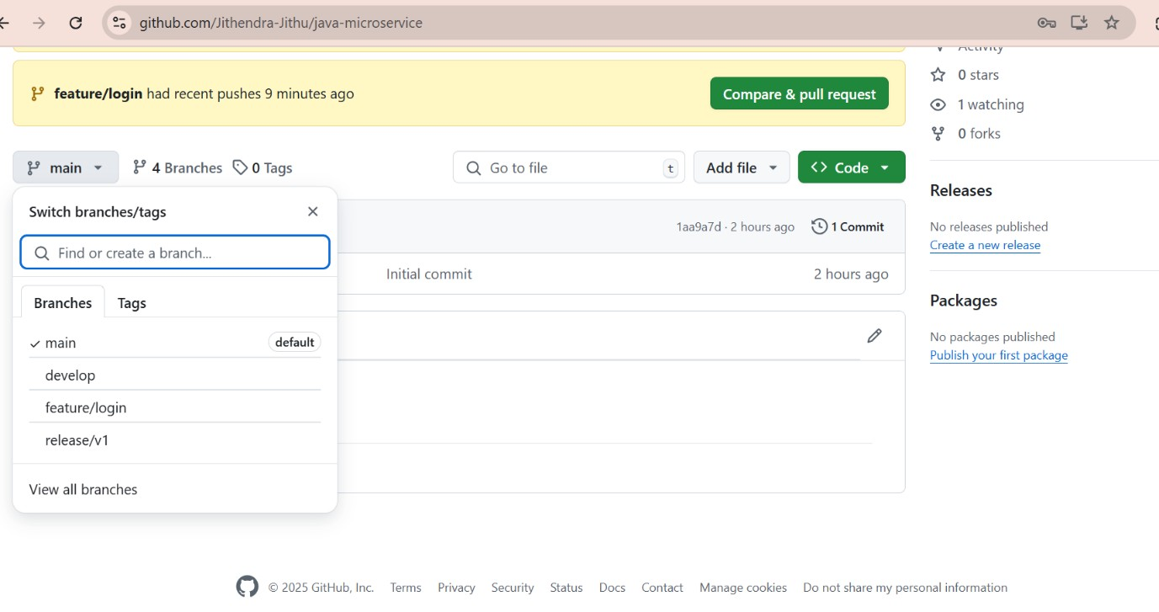

2.Triggers automatically using a GitHub webhook.

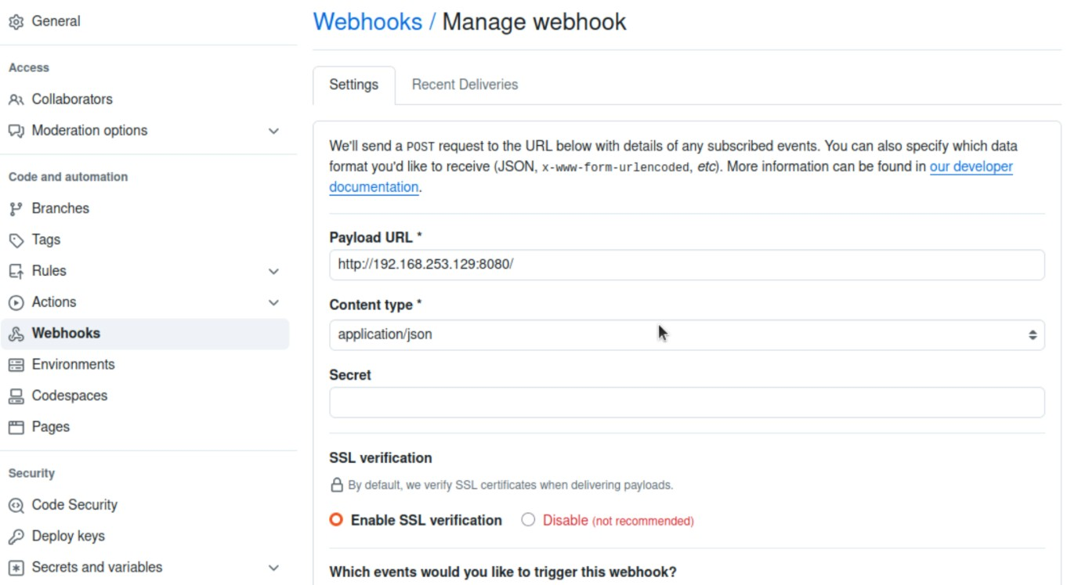

3.Builds and tests the Java application using maven.

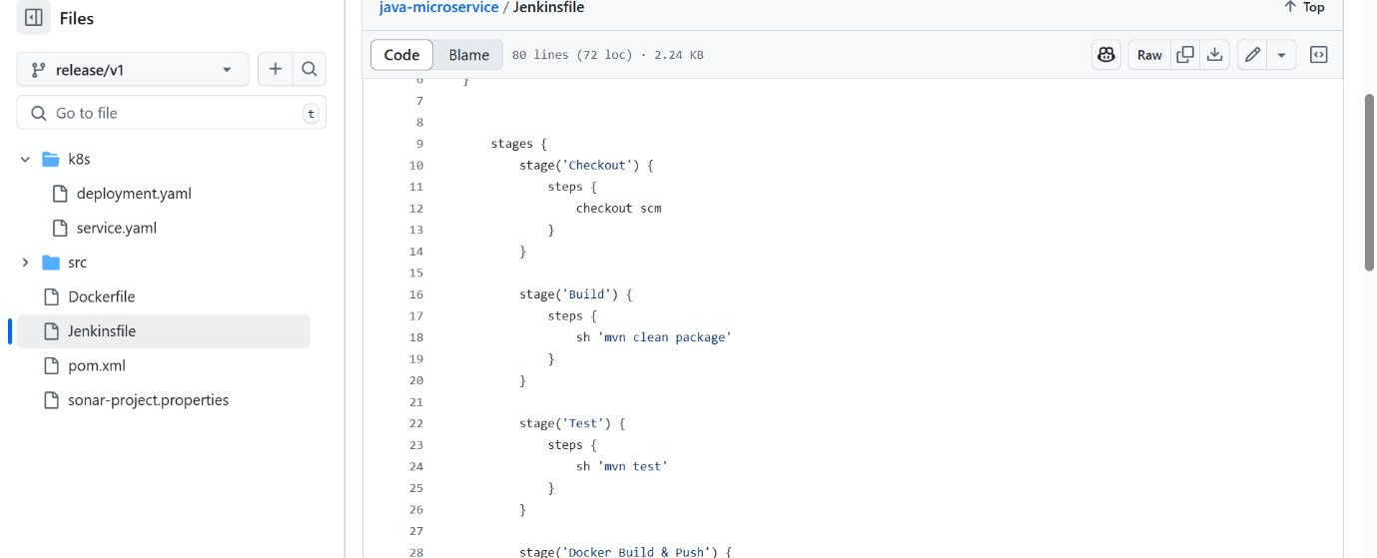

Build history:

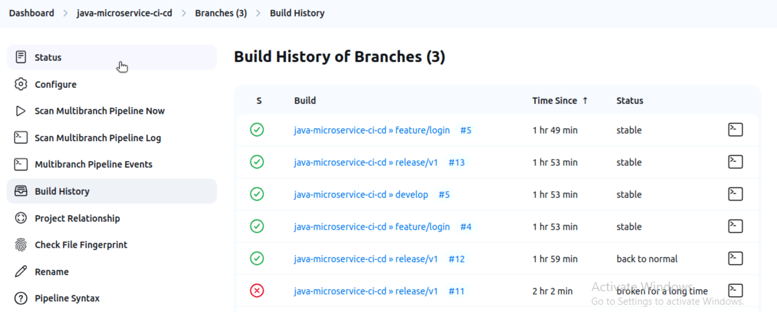

Output of maven:

4. Packages the application into a Docker container and pushes it to an image registry.

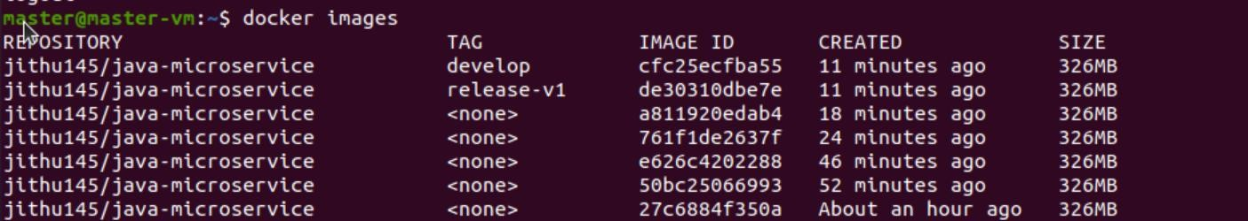

5.Docker Containerization and Image Push

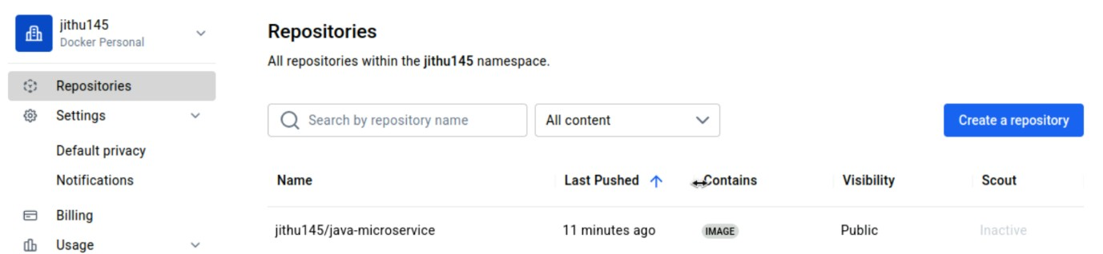

Docker file:

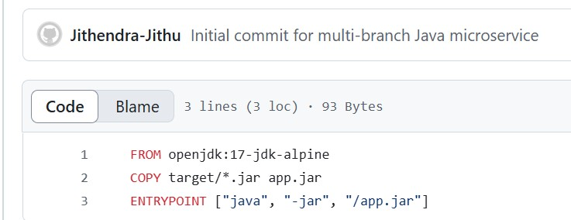

And exposed to 8080

Kubernetes Deployment

1. deployment.yaml (Defines the app deployment and replicas).
2. service.yaml (Exposes the application internally).

b. Add Kubernetes apply command to Jenkinsfile to enable deployment.

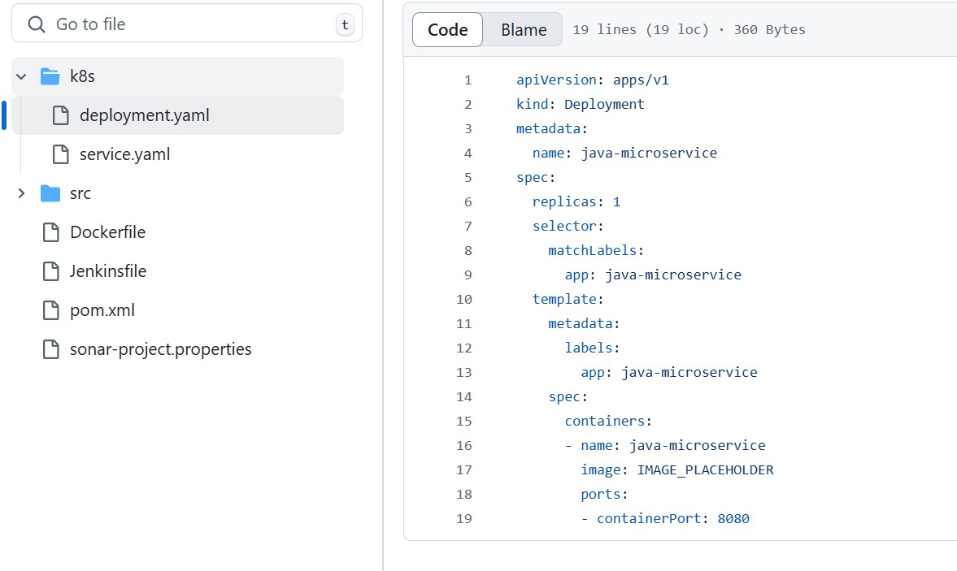

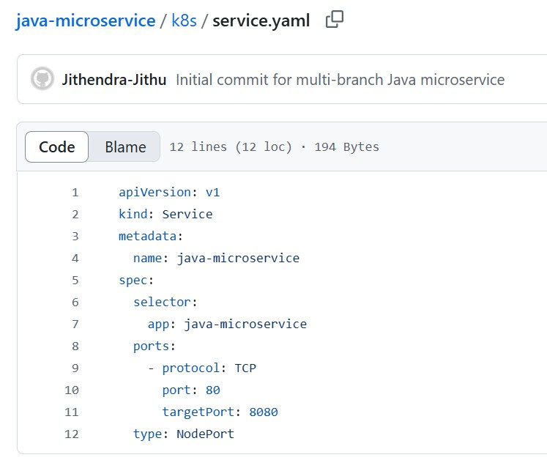

Jenkins file that is written in the code: 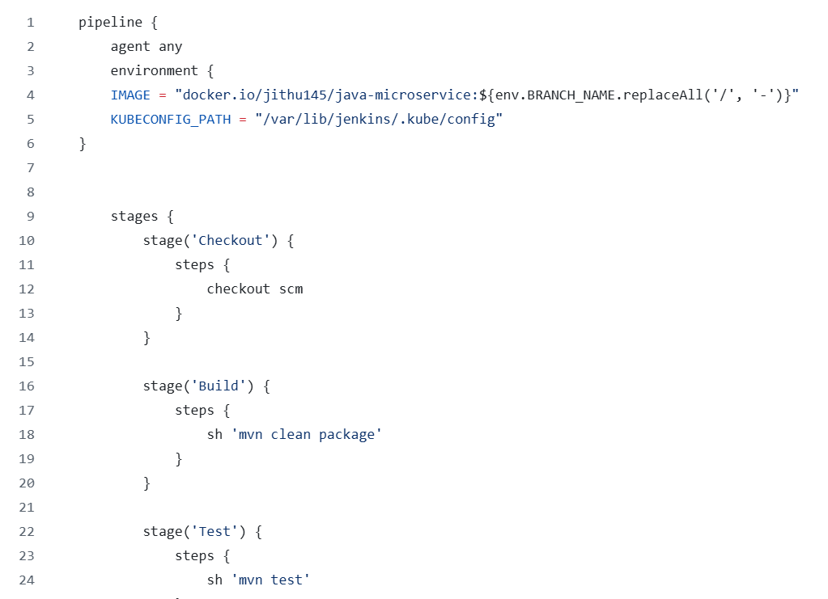

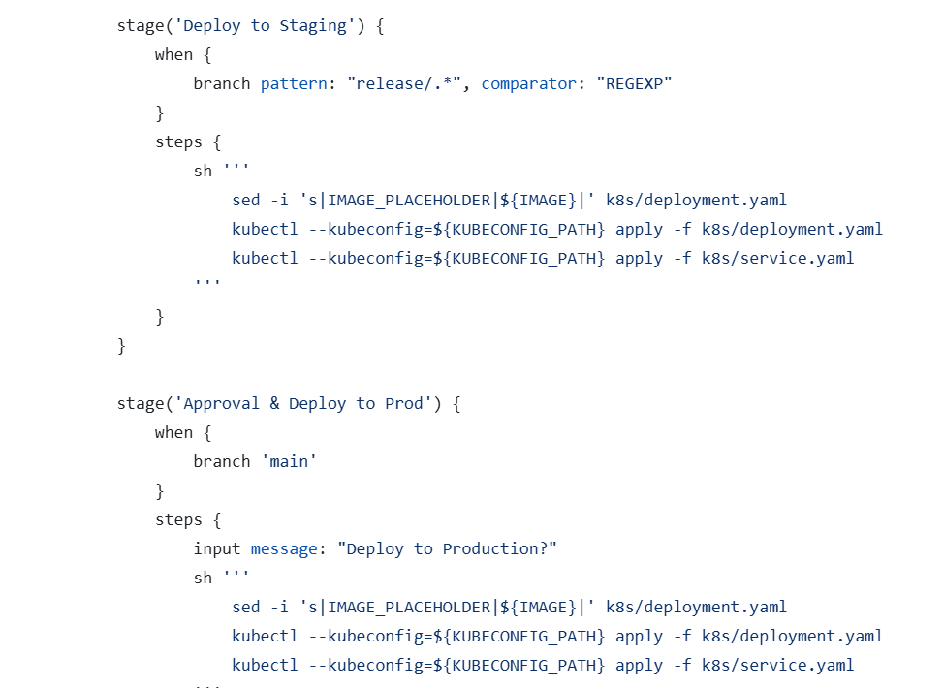

After executing the Jenkins multibranch pipeline:

Output:

Total pipeline output:

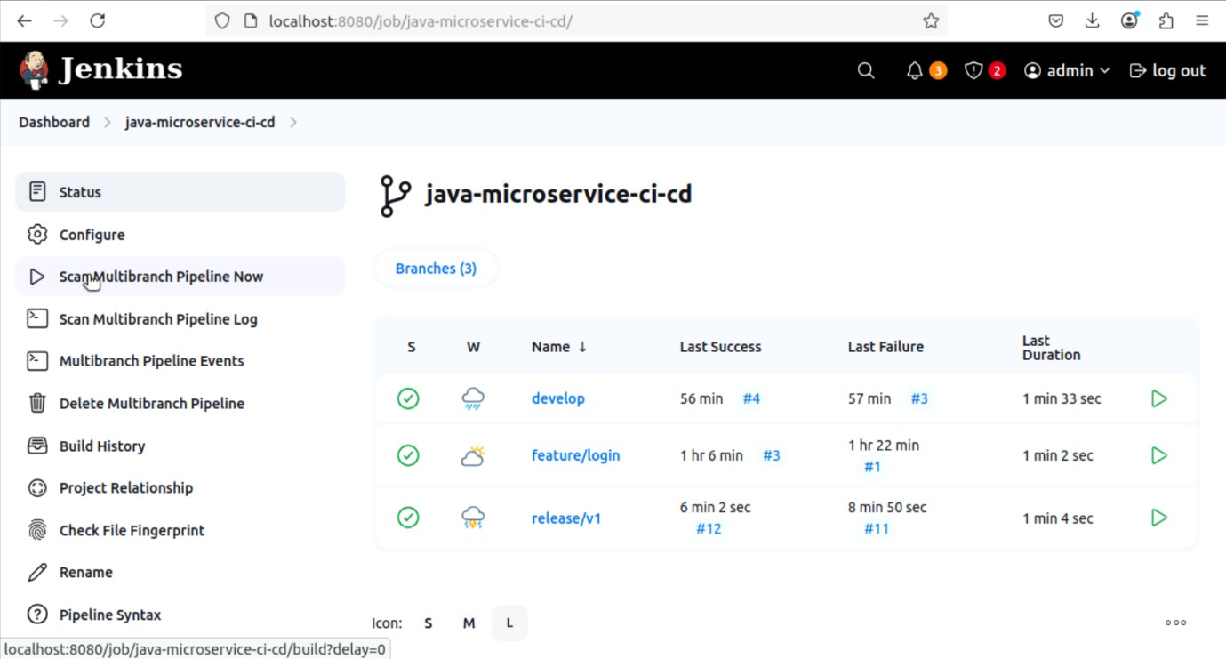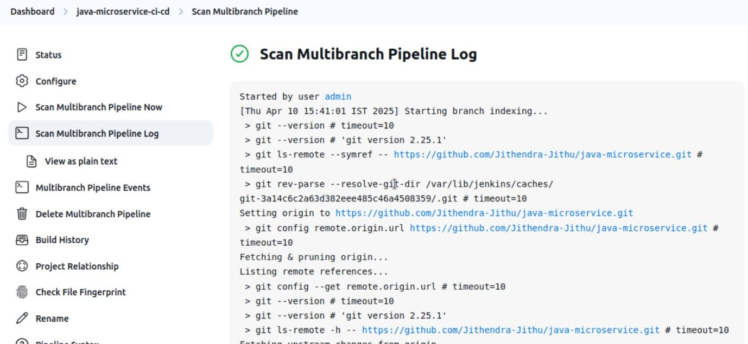

Develop branch:

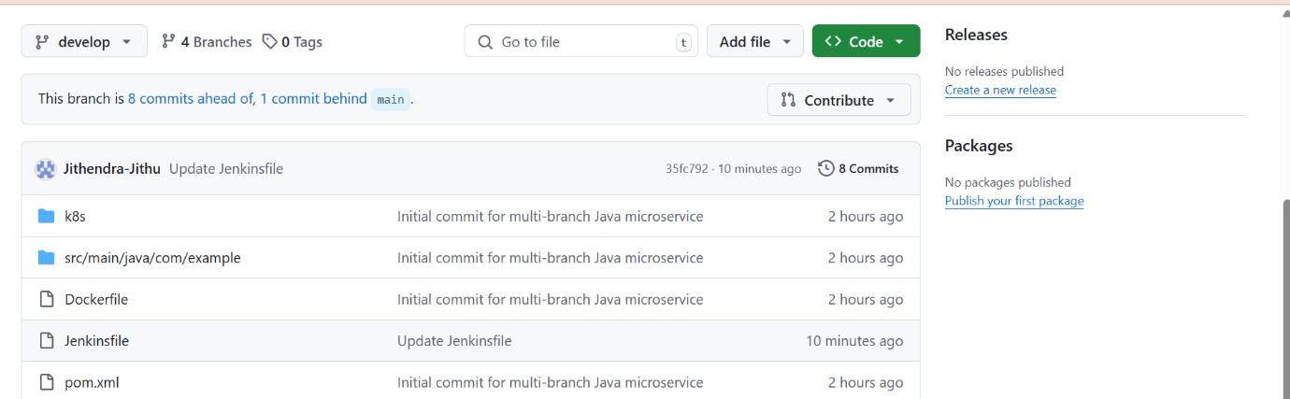

Output:

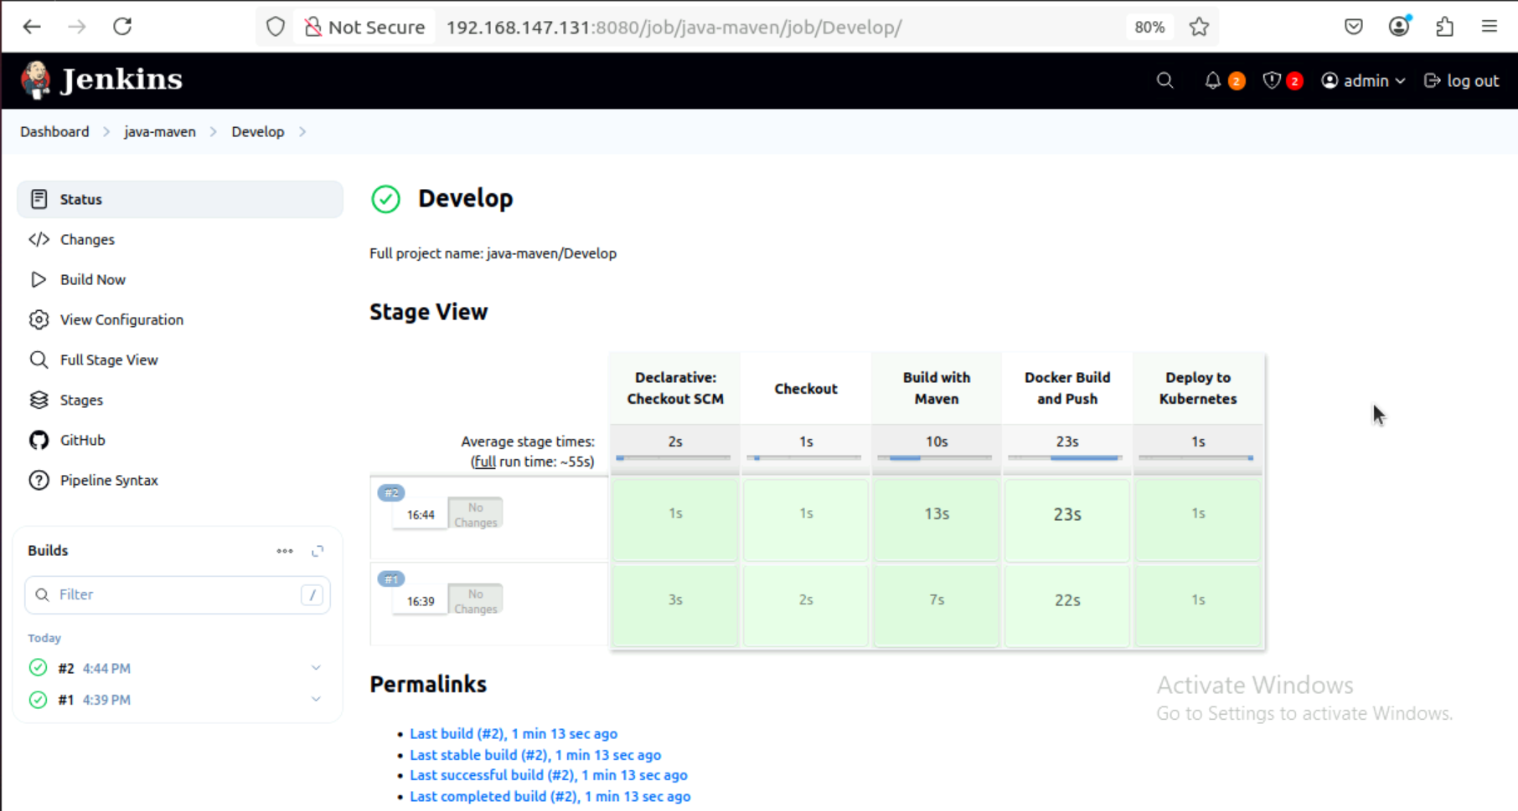

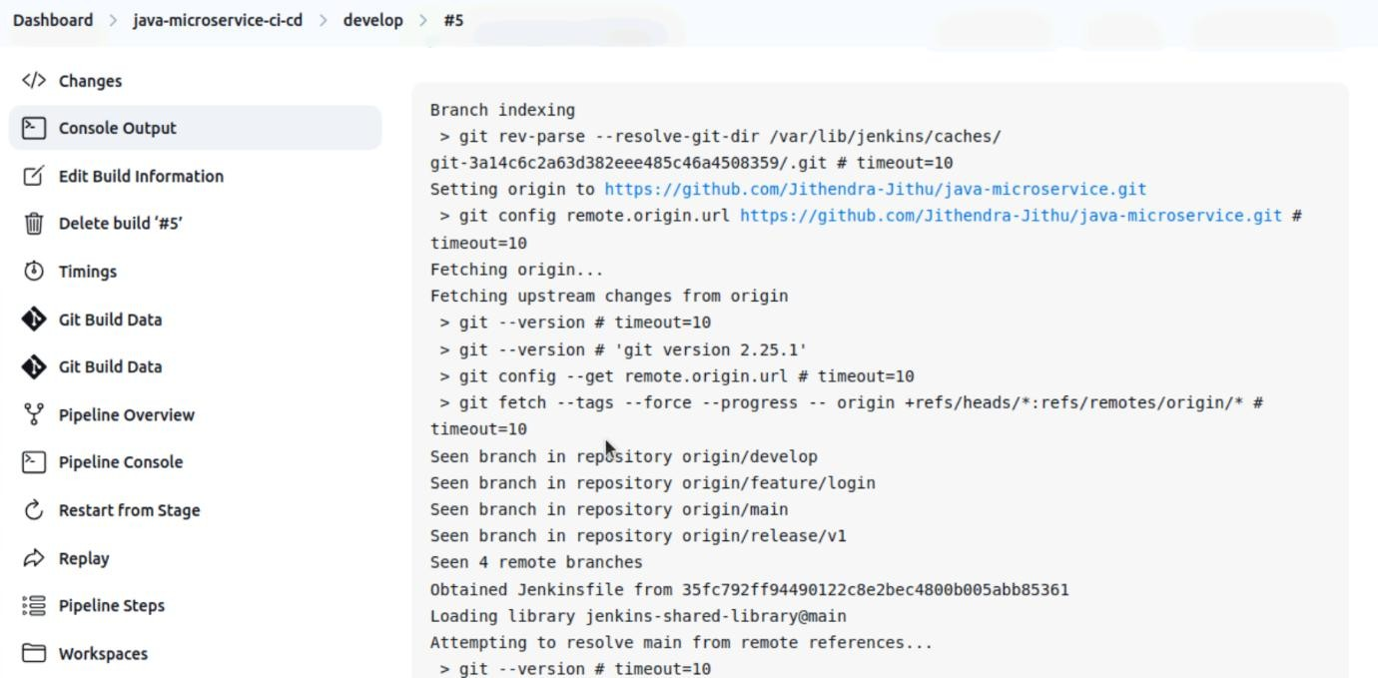

Release branch:

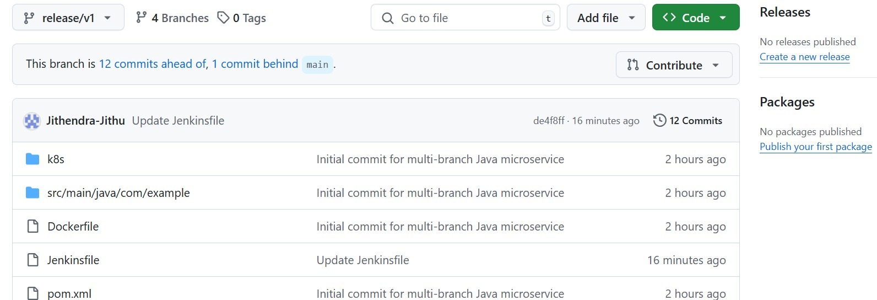

Output:

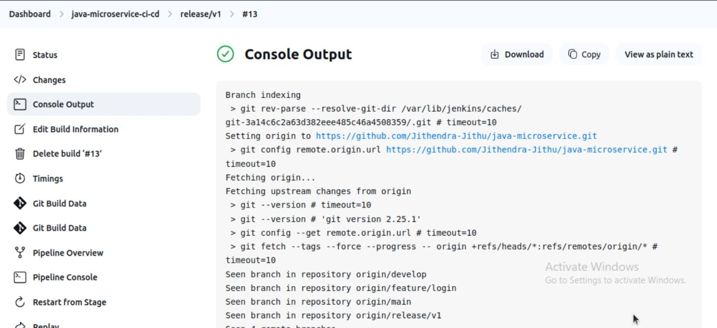

Feature/login:

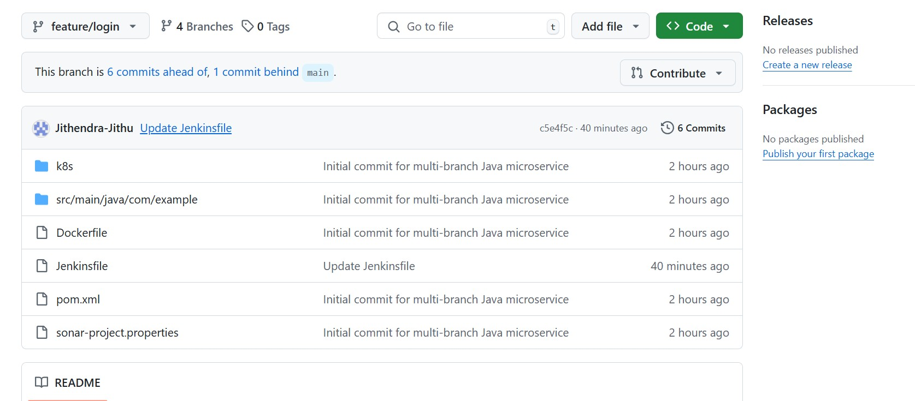

Output:

